Recruitment Pack
Deputy Chief Executive Officer

Thank you for your interest in the post of Deputy Chief Executive Officer.
Since our establishment in 2014, the trust has come a long way and now is the time to appoint a fulltime DCEO who will lead on the development of our school improvement function.
I am particularly excited to be working alongside a colleague who has a passion for teaching and learning and believes that evidence based best practice is a vehicle for school improvement.
As CEO, I am also looking forward to adding to our already talented central team. I am sure that alongside maintaining a keen focus on teaching and learning, the successful candidate will be able to support in all areas of the organisation.
I wish you well with your application and look forward to hearing from you.
Dave Dickinson CEO
Thank you for taking the time to read our Deputy CEO Recruitment pack.
All children deserve access to the very best leaders and teachers and we are no different to others in our quest to appoint an exceptional candidate.
Trustees are looking for an outstanding practitioner with the ambition to lead the development of our school improvement function and make our trust one of the leaders in the delivery of evidence based best practice.
In return we can offer a welcoming environment. One where everyone is valued, opportunities are shared and success truly is a shared experience.
If you are confident that you have the skills, drive and vision to make that a reality, we sincerely hope that you will apply.
Becky Cook Chair of Trustees

Our Vision
Waterton Academy Trust’s vision is to create a collaborative of outstanding schools that possess strong purpose, direction and shared objectives. Where teaching and learning is paramount and children enjoy and engage in a rich and relevant curriculum personalised to their individual needs. Our vision is to create and foster a culture of high aspiration amongst all students, one where all children reach their full potential regardless of their social, economic or cultural background. The Trust will lead and support an enterprise for excellence in teaching and learning that promotes an ethos of lifelong learning for all and ensures success truly is a shared experience.

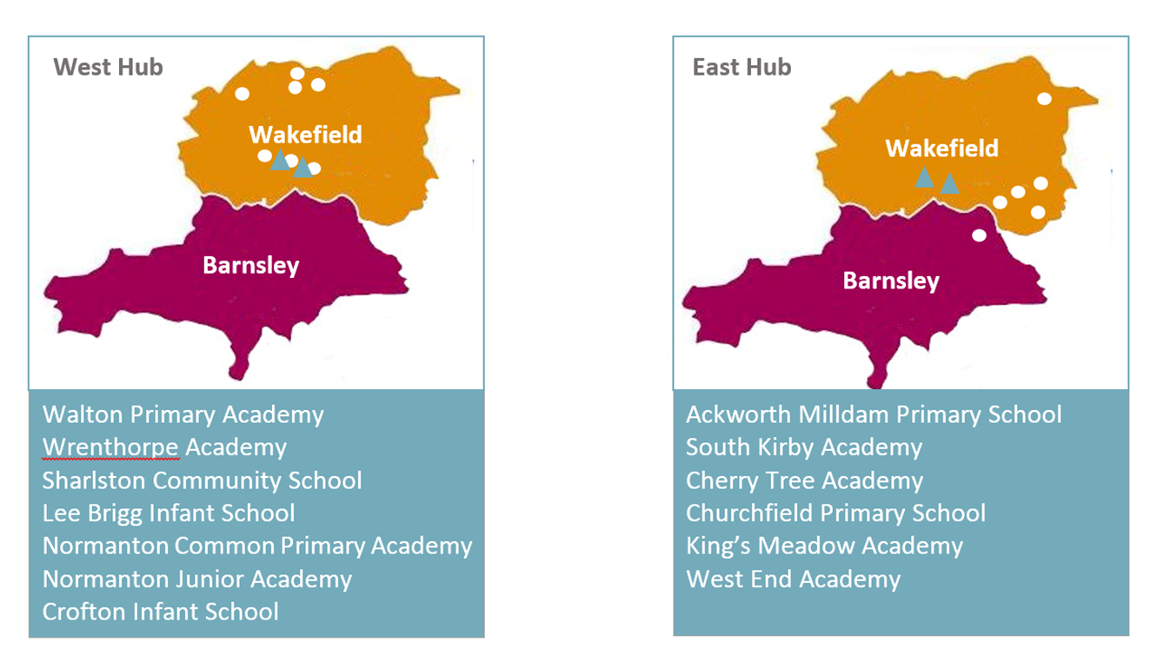
Hub Arrangements:
The result of appropriate growth over a number of years has resulted in the Trust creating a hub model in order to comply with the Partnership Area element of the Conditions of Care. The benefits of the hub are many fold and include ease of commute, streamlined governance, greater collaboration and freeing up of potential growth opportunities. The previous strategy of remaining within LA boundaries has been replaced with a simple proximity discussion. The hub model that is now established currently extends across two LA borders and likewise two RSC regions.

Leadership Structure
The CEO leads the senior leadership team. The COO is responsible for the delivery of all central services other than finance. The CFO leads on Finance. The DCFO will lead the School Improvement Team and deputises for the CEO. Headteachers lead at academy level.

CEO
DCEO
COO
CFO

HT
HT
HT
HT
HT
HT
HT
HT
HT
HT
HT
HT

HT

HT

Governance Structure
The newly formed hub structure is the result of a trust commissioned NGA review. It has been designed to be sustainable and scalable and aligns with the current growth strategy.

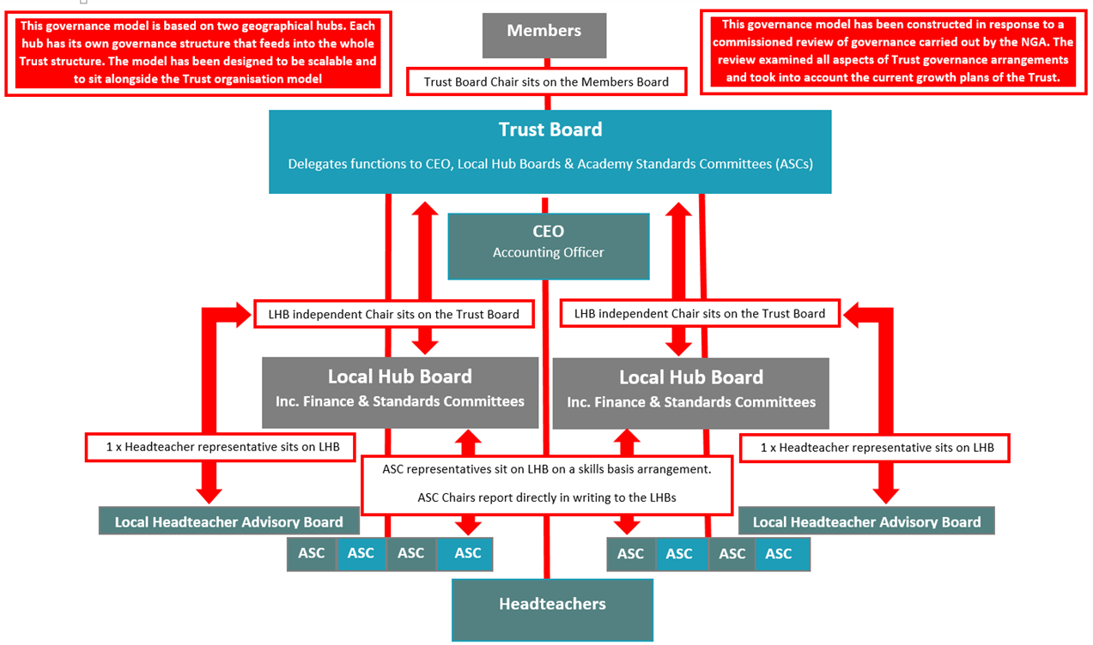

Our Academies
Our academies are all primary phase and are located within the West and South Yorkshire areas. We are proud that every one of our academies joined the Trust of their own free will. Nine of our academies joined the Trust as convertors, two joined under sponsored arrangements and two through re-brokerage.
We aim to continue to grow our family of schools in line with our conditions of care.

More Information
We hope that the above gives you an insight into what we believe is a very special organisation. However, we are sure that you will want to know more about us and the way that we work. There are numerous ways that you can do this:
Visit our website: www.watertonacademytrust.org
Email to: admin@watertonacademytrust.org
Arrange a visit or a chat: 01924 240767

Trust Deputy Chief Executive Officer
Reporting to: The Chief Executive Officer (CEO)

Job Description and Person Specification

The Deputy CEO reports directly to the CEO.
The Deputy CEO has a primary role focus as Leader of Education Standards. In their wider role as Deputy CEO, however, they will be expected to contribute and be influential in all areas of the Trust’s operations.
The Deputy CEO will lead the school improvement team and academy senior leaders in the development and delivery of a school improvement function that is built upon evidence based practice.
The Deputy CEO supports the CEO in setting the vision and purpose of the organisation. They ensure that the organisation reflects and lives the ethos and values set by the Board of Trustees and delivers the strategic goals set by the Board.
The Deputy CEO ensures that the Trust’s activities remain consistent with the charitable objects of the Trust and supports the CEO to ensure governance is compliant with the spirit and letter of the Trust’s Articles of Association and charity and company law more generally.
The Deputy CEO is a member of the Trust’s Executive Leadership Team. They are required to deputise for the CEOs functions and if necessary take decisions and actions collectively with other members of the Executive Team. In the absence of the CEO the post holder acts as the Accounting Officer with responsibility for ensuring that the Multi Academy Trust always acts in compliance with Education Funding Agency regulations and the Trust’s Master Funding Agreement with the Secretary of State. The Deputy CEO is accountable to the CEO. However, under circumstances where the Board determines that the CEO is not able to perform their duties, the Deputy CEO will report directly to the Chair (acting on behalf of the Board of Trustees).
The Deputy CEO’s role includes the Leader of Education Standards functions and in this capacity is responsible for commissioning and overseeing executive education functions of the Trust and the education performance of the Trust.
The Deputy CEO will lead a team of dedicated school improvement professionals from within the central team.
The Deputy CEO, in partnership with the CEO, provides an outward face of the Trust and is responsible for promoting an external world view of the Trust that reflects our charitable objects, our values and secures our positive reputation.

Primary Responsibilities of the Role

Work with the CEO, Board of Directors, Regional Boards, Local Governing Bodies and staff to deliver the Trust’s vision, aims and objectives through inspirational and motivational leadership, clear strategic direction, demanding and measurable targets and supporting development plans.
Lead the development and implementation of the educational strategy to secure the Trust’s agreed values, curriculum principles and organisational behaviours.
Work with senior colleagues at all levels to challenge, motivate and empower them to attain ambitious outcomes that maximise the educational and personal development of pupils and which meet the demands of the wider communities served.
Support and secure delivery of excellent teaching and learning throughout all academies within the Trust through the promotion of high-level professional standards, and rigorous monitoring and evaluation of teaching quality and pupils’ achievement.
In consultation with all internal stakeholders determine and implement curriculum principles and related assessment that enhances learning outcomes for all pupils.
Develop a culture of personal responsibility, recognising excellence and implementing strategies to address under performance, including an effective system of professional development.
Remain abreast of educational developments impacting on Waterton Academy Trust and its academies, both locally and nationally, and ensure senior leaders are well briefed and operate within a flexible environment that is responsive to change.
The Academy Trust must ensure that each of its academies is at the heart of its community, promoting community cohesion and sharing facilities with other schools and/or other educational institutions and the wider community.
The Deputy CEO will ensure that children’s progress and educational achievements meet national expectations as a minimum and the Trust’s agreed ambitions to go beyond that.

Governance

Board of Trustees
The Deputy CEO will work in close partnership with the CEO, Chair and the Board and develop a relationship based on openness, transparency and absolute integrity.
The Deputy CEO, alongside the CEO, will ensure that Trustees have access to all relevant education data, information and options to support their decision-making.
The Deputy CEO will act in compliance with the Board’s scheme of executive delegation.
The Deputy CEO will ensure that all tiers of governance, defined in the Trust’s scheme of governance, are appropriately supported to provide effective governance of the Trust’s education performance.
The Deputy CEO will ensure that systems and reporting structures are in place so that the Board are able to effectively, appropriately and proportionately govern the strategic and operational education risks of the Trust.
Executive Leadership and Management
The Deputy CEO will work with the CEO in appointing staff across the Trust and its Academies.

Vision and Strategic Direction

The Deputy CEO is responsible for supporting the CEO and Trustees in ensuring that the ethos and values of the Trust are translated into an education vision and strategic plan that contributes to the Trust’s wider vision and strategic plan.
The Deputy CEO will inspire and influence internal and external stakeholders to sign up to the Trust’s vision and commit to its realisation.
The Deputy CEO provides the strategic leadership for the school improvement team and academy headteachers.
The Deputy CEO will ensure that education service plans and school development plans align with the Trust’s strategic plan.

Performance Management

The CEO is responsible for Deputy CEO’s performance management.
The Deputy CEO will be responsible for the performance management of the School Improvement team
The Deputy CEO will contribute to the Trust’s quality assurance framework assessment of the effectiveness of the Trust’s education functions and its use to inform priorities for development planning.
The Deputy CEO contributes to ensuring that the Trust has robust policies, procedures and systems for the collection, analysis and interrogation of education performance data at the level of the pupil, class, year group, academy, region and Trust.
The Deputy CEO will ensure that education performance data informs priorities for action at all levels of the Trust.
Alongside the CEO, the Deputy CEO will ensure that systems ensure that each academy’s performance assessment is robustly moderated and verified to maintain an accurate and up-to-date assessment of each school’s educational strengths and weaknesses.

Financial Management

The Deputy CEO will work closely with the CEO, CFO and COO to ensure the responsible and sustainable management of financial and capital resources of the Trust.
The Deputy CEO will ensure that all functions for which they are responsible will operate within the financial limits that have been approved. They will always act financially responsibly and consistent with the principles of good public financial management and charity financial management.

External Relationships

The Deputy CEO, working closely with the CEO and senior management colleagues, will be part of the outward face of the Trust. They will establish and develop external relationships that contribute to the realisation of our charitable objects.
The Deputy CEO will play an active role within the system leadership environment, both locally and regionally.
The Deputy CEO will reflect the values of the Trust in their behaviours and working with external partners and the media.
The Deputy CEO will contribute to the Trust having influence in wider education policy formulation.
The Deputy CEO will contribute to the Trust’s media relationships are managed to be consistent with our charitable objects and the Trust’s ethos and values.

Focus on Learners

The Deputy CEO will ensure that at all levels and in all of its functions the Trust’s primary focus will be on securing a positive learning experience for every young person in each of our academies.

Person Specification
Essential | Desirable | Evidence
Qualifications and Experience  - Qualified teacher status.  - A continued commitment to own professional development.  - Successful record as an Executive  Headteacher, Principal or Head teacher of a school/academy  - Detailed and up-to-date knowledge in subject, national policy, classroom management strategies, inspection procedures and statutory requirements.  - Knowledge of child-safeguarding issues and successful use of measures that promote and ensure the safeguarding of children.  - Experience of school inspection or school to school support | Qualifications and experience  - NPQH.  - NLE Status  - Relevant postgraduate qualification.  - Further relevant professional studies.  - Experience of leading/managing complex/multiple organisations or trusts and sites.  - Experience of having led a school to outstanding or out of a category.  - Experience of more than one key stage.  - Experience of Academy leadership | - Application form  - Certificates  - References

Leading strategically  Knowledge and understanding of:  - Models of effective leadership and organisational structures.  - New technologies and their potential impact.  - Strategic planning processes, tools and techniques.  - Ways of achieving stakeholder and community engagement.  - Leading change, creativity and innovation.  Skills:  - Build capacity and achieve sustainability.  - Deal with complexity and uncertainty.  - Think strategically, analytically and creatively.  - Build a vision and communicate clear purpose and sense of direction.  - Anticipate, lead and manage change.  - Use research to support and challenge practice.  - Inspire, challenge, motivate and empower others to attain challenging outcomes.  - Celebrate achievement and acknowledge excellence.  - Model the vision and values of the trust.  - Work strategically with board of directors.  - Evidence of collaborative and inspirational leadership skills.  - Demonstrate enthusiasm and commitment to leadership aimed at making a positive difference to children and young people and to raising standards.  - Ability to work with support and support groups of school leaders and governors. | Leading strategically  - Experience of designing leadership and management structures in education settings.  - Evidence of successful management of change.  Skills:  - Demonstrate political acumen. | - Application form  - Letter of  Application  - References  - Interviews
Leading teaching and learning  Knowledge and understanding of:  - Methods to ensure the specified teaching standards are harnessed and maintained by all teaching staff.  - Curriculum design and management.  - Principles of quality learning, teaching and assessment including academy review and self-evaluation.  - Use of external support and expertise.  - Behaviour and attendance management.  - New technologies to support learning and teaching.  - Strategies for improving outcomes and achieving excellence for all.  - Tools for data collection and analysis.  - Experience of monitoring and improving the quality of teaching and learning.  Skills:  - Thorough understanding of curriculum design, development and delivery.  - Demonstrate equality and diversity in teaching and learning.  - Achieve the best possible learning outcomes for all.  - Use developmental models for teaching and learning.  - Engage parents in pupil’s teaching and learning.  - Manage and use performance data.  - An excellent classroom practitioner.  - Develop and use effective assessment and moderation systems. | Leading teaching and learning  Knowledge and understanding of:  - Ways of applying effective practice and research evidence to improve outcomes.  - Political impact of external, community or family factors on learning.  Skills:  - Capitalise on appropriate sources of external support and expertise. | - Application form  - Letter of  Application  - References  - Interviews

- Understand whole school culture of best practice in teaching and learning.  - Understand flexible and comprehensive learning opportunities for all students.  - Evaluate, review and develop systems and structures.  - Experience in the analysis of performance data for the purposes of target setting and evaluation.  - An understanding of and competent use of ICT/technology to enhance the quality of teaching, learning and administration.  Leading the organisation  Knowledge and understanding of:  - Employment market, effective recruitment, deployment and management of staff.  - Technology to enhance organisational effectiveness.  - Strategies to maximise contributions from the workforce.  - Accountability frameworks.  - Legal issues relating to leading and managing an academy trust, derived from all relevant statutory and regulatory frameworks.  - Strategic financial planning, budget management and principles of best value.  - Organisational development, planning and implementing change.  Skills:  - Seek expertise and advice from within and outside the trust.  - Delegate, collaborate and distribute leadership.  - Manage others within an accountability framework.  - Create an environment which enables people to perform at their best and underpins effective employee relations. | Leading the organisation  Knowledge and understanding of:  - Development of and access to school buildings and facilities management  - Project management techniques.  Skills:  Manage industrial relations.

- Manage an academy’s financial, human and physical resources.
- Establish structures and systems so operational decisions are based on informed discussion.
- Develop and sustain a safe, secure and healthy academy environment.
- Create a working environment which takes account of workload and work-life balance.
- Proven ability to develop, communicate and successfully implement strategies.
- Numeracy skills for the purposes of interpreting statistical data, and financial information.
- Excellent organisational skills.
- Proven ability to lead an organisation successfully through a period of change.
- Demonstrate personal and professional integrity, including modelling values and vision.
- Commitment to support the aims of the multi-academy trust.

Leading people  Knowledge and understanding of:  - Significance of interpersonal relationships, including impact on teacher performance and pupil learning.  - Performance management, continuous professional development and sustained school improvement.  - Building motivation, including the importance of celebrating achievement  - Own performance, ways of obtaining feedback and how to improve.  Skills  - Develop self-awareness, self-management and self-confidence and use effectively.  - Listen, reflect and communicate effectively  - Monitor and evaluate work of others, give feedback and provide support/intervention to improve  performance  - Hold people to account and challenge under performance  - Develop a culture of learning and continuous professional development.  - Receive and act on feedback to build on strengths and improve personal performance.  - Create a culture which encourages ideas and contributions from others.  - Foster an open, fair and equitable culture.  - Proven ability to motivate, challenge, develop, empower and sustain individuals and teams.  - High standards of personal and professional conduct.  - Proven experience of developing good working relationships with all stakeholders.  - Proven ability to generate and deliver collective vision and shared purpose at pace.  - Proven ability to create, build and retain effective staffing structures.  - A sense of humour! | Leading people  Knowledge and understanding of:  - Building and sustaining a learning community within a diverse workforce.  - Support and development systems for individuals and teams.  - Have a high level of Emotional Intelligence and use it  Skills  - Negotiate and manage conflict, providing appropriate support. | - Application form  - Letter of  Application  - References  - Interviews

Leading in the community  Knowledge and understanding of:  - Multi-agency work (including the team around the student), benefits and risks of multi-agency working.  - Collaboration and partnership working (including academy, home, community and business partnerships).  - Wider curriculum beyond the academy and opportunities it provides.  - Diversity and community cohesion issues.  Skills  - Establish and engage in partnerships, including working with multi-agency teams.  - Consult, engage and communicate with staff, students, parents and carers to enhance pupils’ learning.  - Engage in cross phase working and transition issues.  - Collaborate and work within and across the community.  - Engage the community in systematic evaluation of the trust’s work and act on outcomes. | Leading in the community  Knowledge and understanding of:  - Extended service provision, commissioning and contracting.  - The diversity of professional cultures and ways of working.  - Strengths, capabilities and objectives of other schools and academies, services and agencies.  Skills  - Take a leadership role within and across the community.  - Engage in academy-to-academy collaboration and contribute to leadership in the wider education system.  - Contribute to achievement of community cohesion.  - Broker and commission services. | - Application form  - Letter of  Application  - References  - Interviews

