James Courtney
Chief Fire Officer & Chief Executive

Date: | January 2019 |  |  |  |  |  | 197 Eyre Street  Sheffield  S1 3FG  Tel: 0114 2727202  Fax: 0114 2532266
Your Ref: |  |  |  | Our Ref: | JC/DB
This matter is being dealt with by: |  |  | CFO. James Courtney
Tel Direct line: |  | 0114 2532201 |  | Fax Direct line: |  | 0114 2532200
Email: | jcourtney@syfire.gov.uk |  |  | Website: www.syfire.gov.uk

Dear Applicant,

Deputy Chief Fire Officer

Thank you for your interest in the vacant post of Deputy Chief Fire Officer within South Yorkshire Fire and Rescue. This appointment will provide an exciting and challenging opportunity for an individual who wishes to make a real contribution to how we shape our fire service in the future and who is passionate about delivering a significant social impact. The Fire Authority is looking for an accomplished leader who will work with me to build on our strong foundations and significant experience to create an environment for our staff to flourish and our service to reach its full potential. You should be someone who will bring fresh ideas and strengthen our relationships in core areas where we believe we are best placed to make a substantial difference. The challenges we continue to face will require innovation and change in conjunction with a sophisticated, empowering approach to realising potential and achieving our ambitious aims.

A copy of the job description and person specification is enclosed and we recommend you use these when completing your application.

Your application will include the following elements:

- Full fire service or career history

- A supporting statement which includes evidence of experience/ability in the following areas:

- Delivering transformational change
- Galvanising a traditionally cautious workforce
- Engaging in a political environment
- Building successful partnerships
- Briefly set out your thoughts on “The Fire Service 5 - 10 years hence”.

1 of 2

Applications must be received by Friday 1 February 2019.

It is your responsibility to ensure that we have received your application. In order to avoid last-minute IT issues, we also ask that you allow yourself ample time to submit your application in advance of the deadline.

Please do contact me if you wish to have an informal discussion about the role or if you have any questions.

Kind regards,

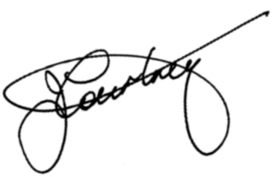
Yours sincerely,

James Courtney
Chief Fire Officer and Chief Executive

2 of 2

