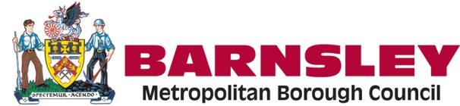
Disabled Facilities Grant Team:
Recruitment Pack
2019

Content Page

- Working for Barnsley Council 2

- Our Communities Directorate 3

2a. Stronger, Safer, Healthier Communities 4

2b. Provider Services 5

2c. Assistive Living Technologies 6

2d. Disabled Facilities Grant 7
3. Warm Homes and Hospital Discharge Team- 8

4. Key strategies for you to consider 9
5. Other great reasons to work for Barnsley Council 9
5a. Work life balance 9
5b. Wider Wallet 10
5c And much more…. 10
6 For an informal chat about the post 11

- Working for Barnsley Council

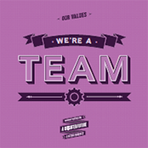

Here at Barnsley, we live and work by four important values: honesty, teamwork, excellent service, and taking pride in what we do. As part of our team, you can be sure we’ll do all we can to support you in being truly excellent. You see, we prioritise learning and enabling you to achieve your potential. So we’ve created a development process that lets you grow in the way that suits you - whether that’s training to be a leader, or learning flexibly online. That’s one of the reasons why we achieved IIP Gold, and why you’ll find your career here inspiring and rewarding.

Working for us is exciting. We’re becoming a more modern, efficient and business minded organisation through planned change, improvement and growth. We’re stronger, more customer focused and more sustainable in the face of increasing pressures and reducing budgets, and there’s so much more we need to do together. This means significant change for us all, and we all have a part to play.

We’ll continue driving growth, helping the people most in need and helping local communities to thrive. We’ll generate more of our own income through business rates and council tax. We’ll plan long term so that we can understand and respond to future challenges. Although financial austerity is still upon us, the opportunities to grow, to do things differently and to use new technology are really positive.

For more information please visit us at:
https://www.barnsley.gov.uk/services/our-council/

- Our Communities Directorate

The Communities Directorate is diverse. It manages Customer Services, Digital First and Stronger, Safer and Healthier Communities.

Our Executive team is:
Wendy Lowder
Executive Director

David Robinson
Service Director,
IT
Phil Hollingsworth
Service Director, Stronger, Safer, Healthier Communities

2a. Stronger, Safer, Healthier Communities

Phil Hollingsworth
Service Director, Stronger, Safer, Healthier Communities

Jayne Hellowell
Head of Healthier Communities
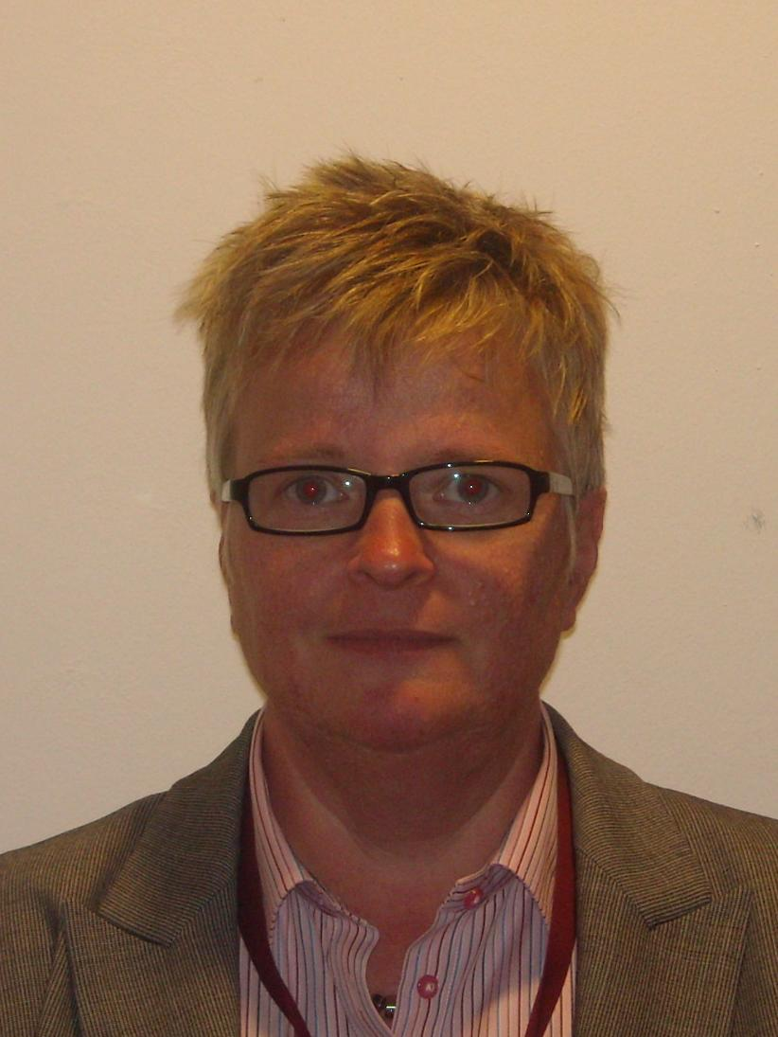
Paul Brannan
Head of Safer Communities
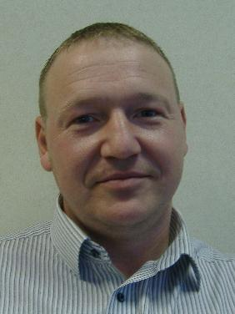
Kate Faulkes
Head of Stronger Communities
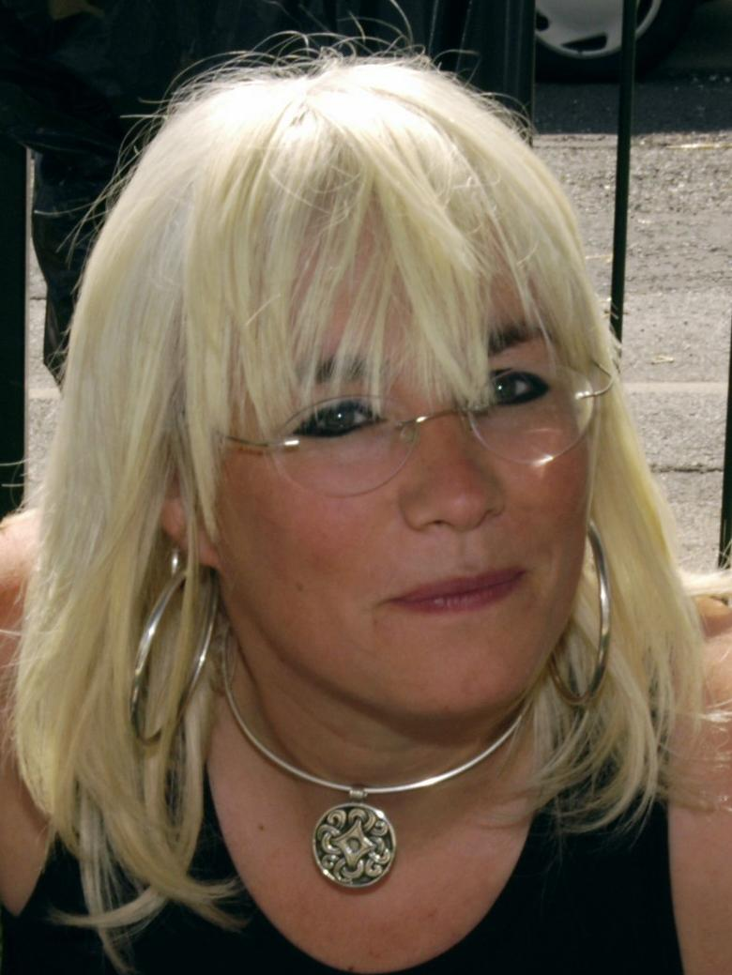
#

The Business Unit is spread over three service areas Stronger, Safer and Healthier Communities. Individually and collectively these services contribute to the full suite of Council priorities but in particular the link to “Strong and Resilient Communities” is where their contribution is most directly reflected. The service also provides a strategic leadership and co-ordination role for the Council in relation to Early Help and Prevention, Community Engagement and the Principal Towns Programme. Our overall aim is to have in place much more succinct services that align to each other and meet with new and emerging trends. A review of the staff structure has taken place to ensure that it is fit to deliver going forward. Central to this is making sure there are firm connections between the three services and that the synergy with other business units is in place. This includes joint working and planning with partners to meet the needs of customers. In line with numerous Future Council strategies you will contribute to early help for all ages, facilitating early help and prevention, promoting independence for vulnerable people in Barnsley.

2b. Provider Services / ABLE
The Provider services structure chart below illustrates where the Disabled Facilities post sits.

Liz Taylor Acting Head of Service

Service Manager
Warm Home service:
Team leader
Info/Support Officer & Case Workers
Assistive Living Technologies:
Monitoring Centre
Installation Team
Responders
Disabled Facilities Grants
Project Managers, Officers & admin Team

You will get a lot of support whilst working with us. You will have a plan for your work with agreed priorities and deadlines. You will be supported to deliver your objectives through regular one to one and annual appraisals. We will support you with training and development and you will have a fantastic opportunity to work in a team that has a varied and exciting portfolio.

Here are some key areas of our business:

2c . Assistive Living Technologies

Technology to help you live independently at home:

Assistive living technology from offers an alternative to home care and residential care for people who need support to live independently, in their own home for longer. Knowing help is always available can puts their mind at rest as well as making them feel safe, and helps people live independently.

Remote monitors:

In addition to the alarm pendant, we offer a range of remote monitors that automatically raise an alert if someone is at risk at home. Examples include:
- fire
- carbon monoxide
- extreme changes in temperature
- a fall in the home
- floods
- bogus callers

Available equipment also includes:

- medication reminders
- door sensors
- bed and chair sensors

Benefits of a Telecare alarm

Instant response - we will respond to your call and get the help you need, when you need it.
Personal service - we offer a friendly and dignified service
We won't leave you - we will ensure that help arrives
Complete reassurance - 24 hour link to the monitoring centre
Easy installation - we will fit and demonstrate the equipment at a convenient time for you
Help via your own mobile phone - We can provide our monitoring service via someone’s own mobile phone, either as an add-on to Telecare or via speed dial. Giving peace of mind knowing someone can be contacted for help, either at home or when someone’s out and about.

2d. Disabled Facilities Grants (DFG)
We are seeking a highly motivated and committed individual to join the Disabled Facilities Grants Team.
The Project Officer post will be responsible for dealing with Disabled Adaptations to properties of residents who need help and support to enable them to remain living in their own homes safely and independently. This will involve assessing Occupational Therapist referrals, undertaking home visits to perform property surveys, formal grant applications and financial assessments. It will also include specifying schedules of work, liaison with contractors and suppliers, problem solving and inspection of works to ensure high standards are achieved. You will also need to collect, monitor and analyse data, so that it can be reported to the Management Team when requested.
You will need to demonstrate that you are self-motivated, a good team player, computer literate, have strong written and verbal communication and have excellent customer focused qualities.
The ideal candidate will be able to evidence an awareness of the technical and construction issues involved to allow them to help design and oversee adaptations for disabled people, such as level access shower adaptations.
Disabled Facilities Grants (DFGs) are a mechanism to provide financial assistance to disabled people who meet the eligibility criteria for housing adaptations which enable the person to live independently in their own home.
In Barnsley the Communities Directorate administers the DFG. The scheme is for children and adults living in private sector residential properties who require home adaptations costing more than £1,000 where it is deemed that the adaptation work is necessary and appropriate to meet the disabled person’s needs, and it is practical and reasonable to undertake depending on the age and condition of the property.
The delivery of DFGs is heavily governed by legislation the Housing, Construction and Regeneration Act, 1996.Under this Act all adults who apply for a grant are subject to a financial assessment of means except those who receive certain types of income who will be deemed to be automatically eligible for a grant.
The maximum grant award available is £30,000 although the Council can apply discretion to ‘top up’ this amount if it is in the interest of the Council and the applicant concerned to do so and an approved policy is in place.
Work funded through a DFG comes under the category of major adaptation work and includes; stair lifts, ramps, provision / building of level access facilities.
Minor adaptation work and equipment (costing less than £1000) to support community care and promote independence for the person is managed by the Equipment and Adaptations team and supplied by the Community Equipment Service.
Our priorities for 2019-20 include:

- Continuing to promote independence for vulnerable people in Barnsley in line with corporate strategy to provide early help for all ages. Facilitating prevention and early intervention.

- Working smarter in line with digital first to promote more efficient and robust working practice for staff and in turn better customer service for all service users.

- Continuing to reduce waiting times for adaptations.

- Introduction of new initiatives such as a framework for Level Access Shower adaptations increasing the number of approved contractors to complete works.

- Warm Homes and Hospital Discharge Team
We are committed to commissioning services that meet the needs of vulnerable people in Barnsley. The new Warm Homes and Hospital Discharge team is key to helping us delivering our priorities and help us address fuel poverty and reduce excess winter deaths in Barnsley.

- Key strategies for you to consider
In preparation for your application you may find the following links to information useful:

Future Council - https://www.barnsley.gov.uk/services/our-council/future-council-2020/

Barnsley Corporate Plan - https://www.barnsley.gov.uk/services/our-council/our-corporate-plan/

Barnsley Place Based Plan - http://barnsleymbc.moderngov.co.uk/mgCommitteeDetails.aspx?ID=143

Other key strategies - https://www.barnsley.gov.uk/services/our-council/key-strategies/

You can also visit to find out more about our services such as Assistive Living Technologies and Disabled Facilities Grants in Barnsley at www.barnsley.gov.uk/telecare & https://www.barnsley.gov.uk/services/housing/disabled-facilities-grants/

- Other great reasons to work for Barnsley Council
5a. Work life balance
We have developed a number of flexible working opportunities that are available to employees some of which include:
- Annualised Hours
- Banked Time Arrangements (Time off in lieu)
- Compressed Hours
- Flexi Hours Scheme
- Homeworking
- Job Share
- Maternity and Adoption Leave
- Maternity and Adoption Support Leave
- Overtime and Additional Hours
- Parental Leave
- Secondment
- Shared Parental Leave
- Shift Working
- Term Time Only Working
- Voluntary Reduction in Working Hours
- Workbreak

5b. Wider Wallet
Wider Wallet is an exciting employee discount site offered through Just4YOU, which provides Barnsley Metropolitan Borough Council employees with privileged access to a tempting package of discounts and benefits.
Your Just4YOU Employee Benefits package is designed to:
Boost your spending power with discounts on day-to day costs including supermarket shopping, high street stores, DIY, motoring and family finance.
Maximise your leisure time with special offers on travel, theme parks, family outings and experience days.
Increase your wellbeing with relaxing spa breaks, free health screening and great value health insurance.

5c. And much more….
There is so much more too including and not limited to:
- Salary sacrifice schemes
- Money saving schemes
- Support with your health and well being
- Appraisals and performance support
- Training and development

6. For an informal chat about the posts
We hope that this recruitment pack has helped you in your application. If you would like to discuss the post further please do not hesitate to contact Bevan White or Peter Firth via 2
bevanwhite@barnsley.gov.uk Mobile: 07590 485260
peterfirth@barnsley.gov.uk Mobile: 07917 051058

Good luck with your application!

